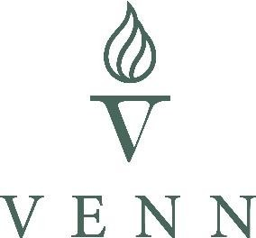

Milton School

Exclusion Policy

Pioneer Inspire Achieve Collaborate Create

**Contents**

1. Aims 3
2. The decision to exclude 3
3. Statutory guidance 3

**…………………………………………………………………………………………………**

# Aims

Our school aims to ensure that:

* + The exclusions process is applied fairly and consistently;
  + The exclusions process is understood by governors, staff, parents and pupils;
  + Pupils in school are safe and happy;
  + Pupils do not become NEET (not in education, employment or training).

# The decision to exclude

Only the Head of School, or acting Head of school, can exclude a pupil from school. A permanent exclusion will be taken as a last resort.

Our school is aware that off-rolling is unlawful. Ofsted defines off-rolling as:

“…the practice of removing a pupil from the school roll without a formal, permanent exclusion or by encouraging a parent to remove their child from the school roll, when the removal is primarily in the interests of the school rather than in the best interests of the pupil.”

We are committed to following all statutory exclusions procedures to ensure that every child receives an education in a safe and caring environment.

A decision to exclude a pupil will be taken only:

* + In response to serious or persistent breaches of the school’s behaviour policy,

**and**

* + If allowing the pupil to remain in school would seriously harm the education or welfare of others

Before deciding whether to exclude a pupil, either permanently or for a fixed period, the headteacher will:

* + Consider all the relevant facts and evidence, including whether the incident(s) leading to the exclusion were provoked
  + Allow the pupil to give their version of events
  + Consider if the pupil has special educational needs (SEN)

# Statutory guidance

The trust strongly feel that exclusions must be used only as a very last resort. On the rare occasion an exclusion is issued, this is carried out in line with current DfE

exclusions guidance. This can be viewed on this link:

<https://www.gov.uk/government/publications/school-exclusion>